ON-THE-JOB ACCOMPLISHMENT REPORT JUNE 2023

| DAY | ACCOMPLISHMENTS |
| --- | --- |
| 1 |  |
| 2 |  |
| 3 |  |
| 4 |  |
| 5 |  |
| 6 |  |
| 7 |  |
| 8 |  |
| 9 |  |
| 10 |  |
| 11 |  |
| 12 |  |
| 13 | Attendance |
| 14 | Preparing papers for OJT |
| 15 | Continuing the preparation for OJT |
| 16 | Arranging the papers for OJT |
| 17 | SATURDAY |
| 18 | SUNDAY |
| 19 | Cleaning Lab C |
| 20 | Continuing Cleaning Lab C |
| 21 | Set up the computer |
| 22 | Preparation of editing picture for graduation |
| 23 | Continuing of editing picture for graduation |
| 24 | SATURDAY |
| 25 | SUNDAY |
| 26 | Continuing of editing picture for graduation |
| 27 | Continuing of editing picture for graduation |
| 28 | Attending the Mass of graduation day and operate in the live wall |
| 29 | Finalization of presentation for graduation day |
| 30 | Cleaning lab |
| 31 |  |

Submitted by: Checked by:

**______________________________ ________________________________**

On-the-Job Trainee Supervisor

Attach your pictures here :

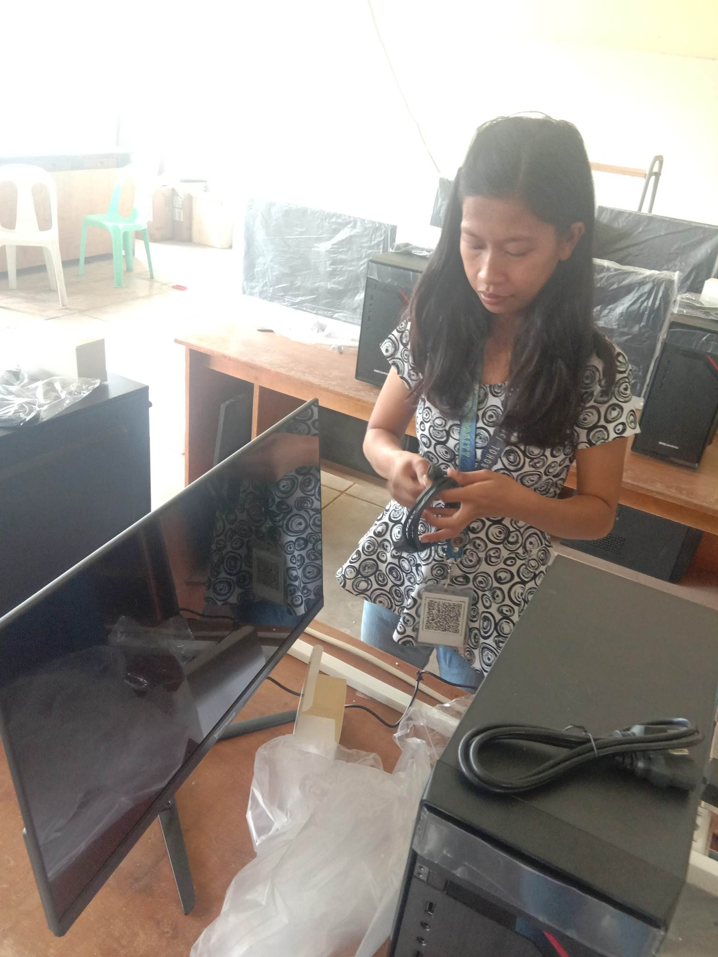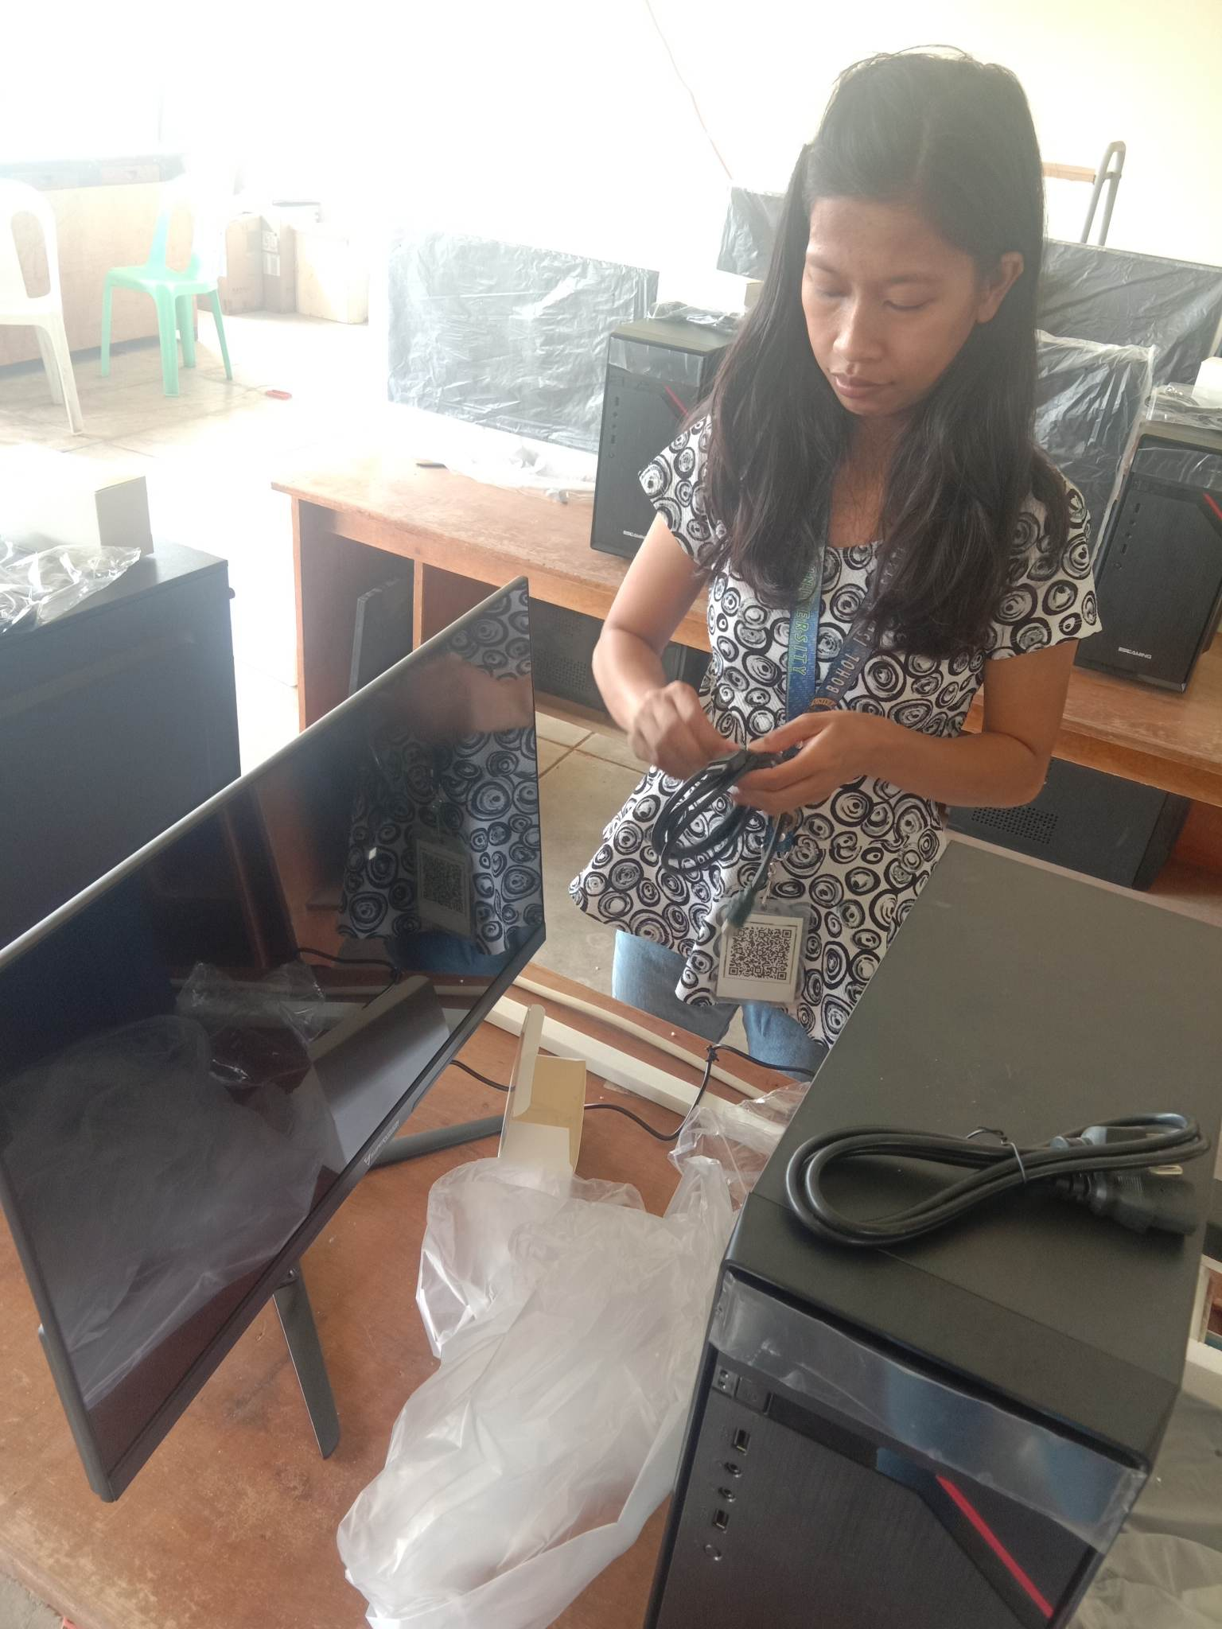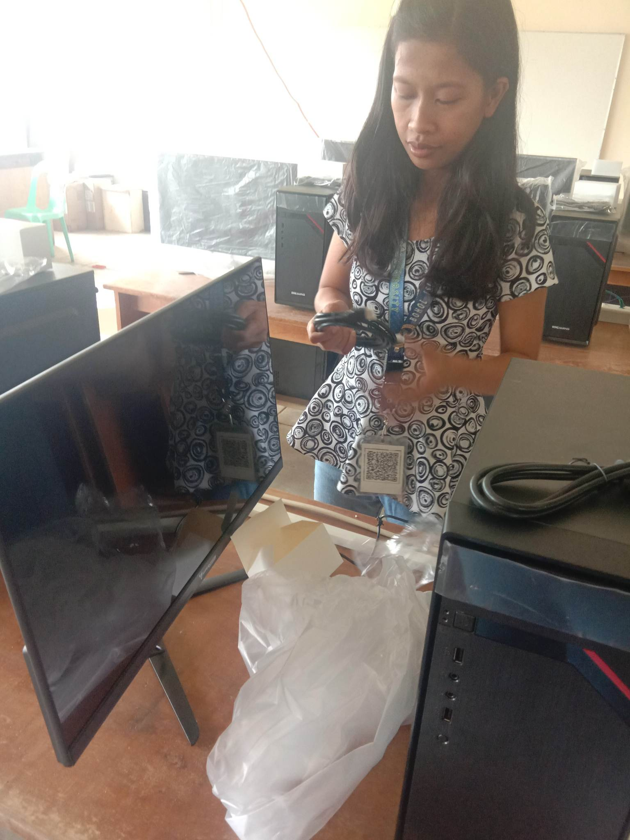

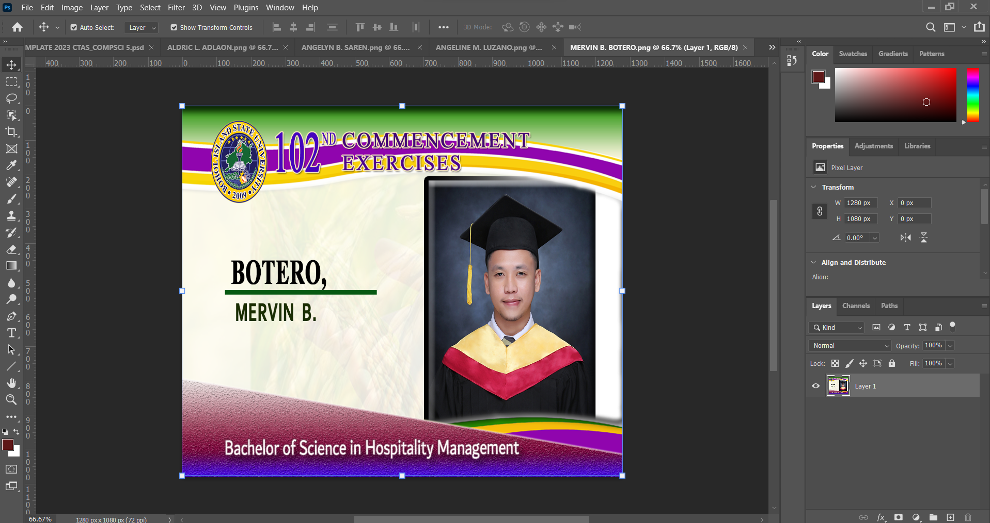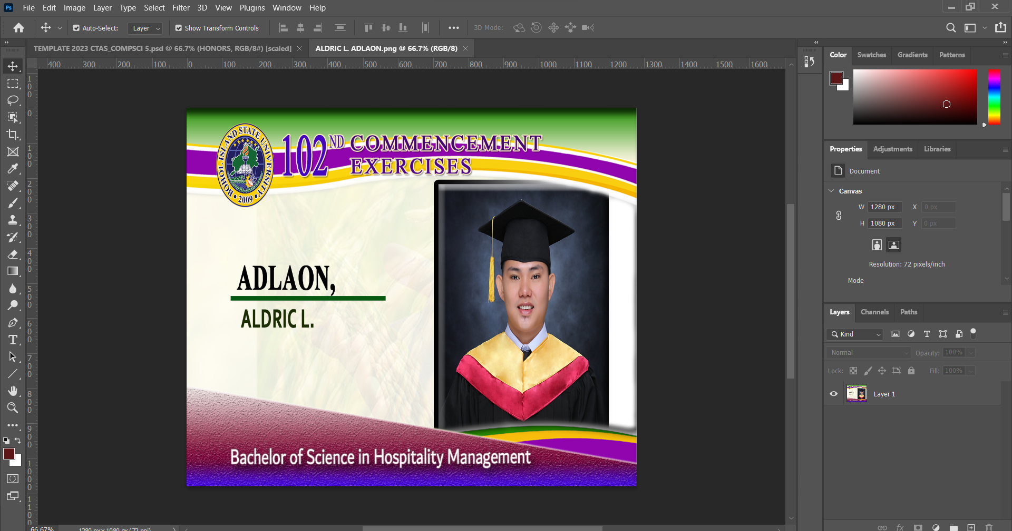

Attach your pictures here :

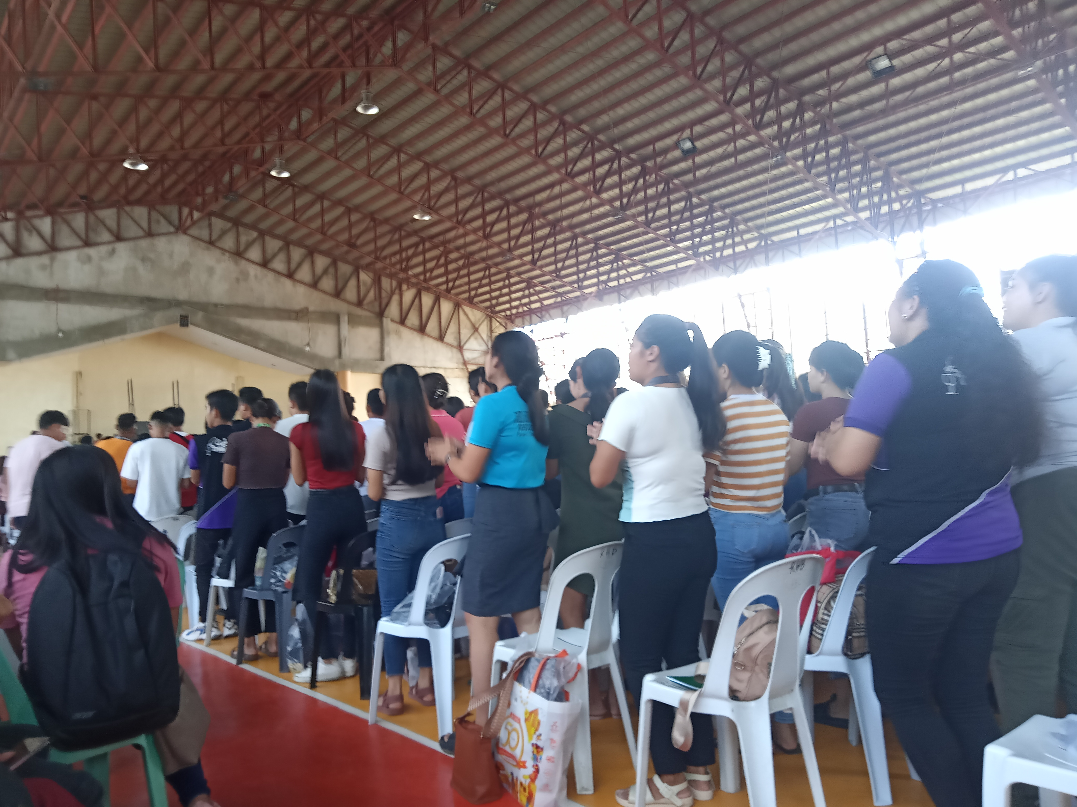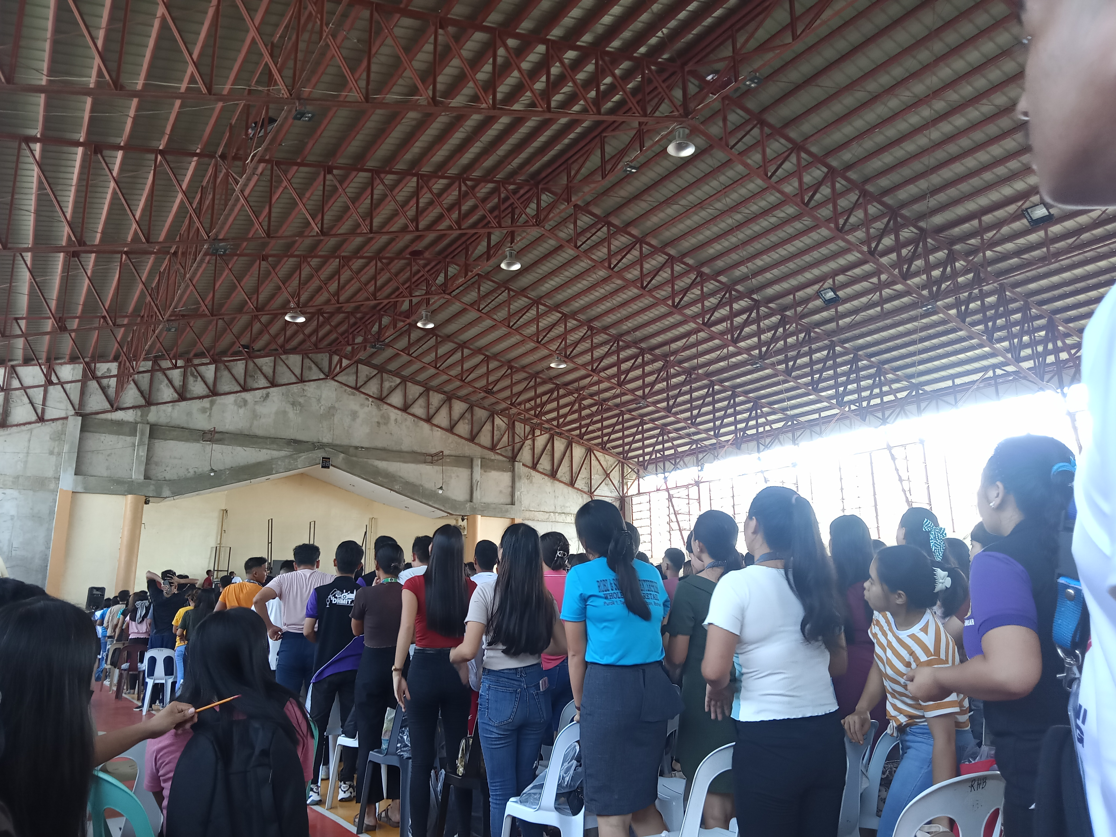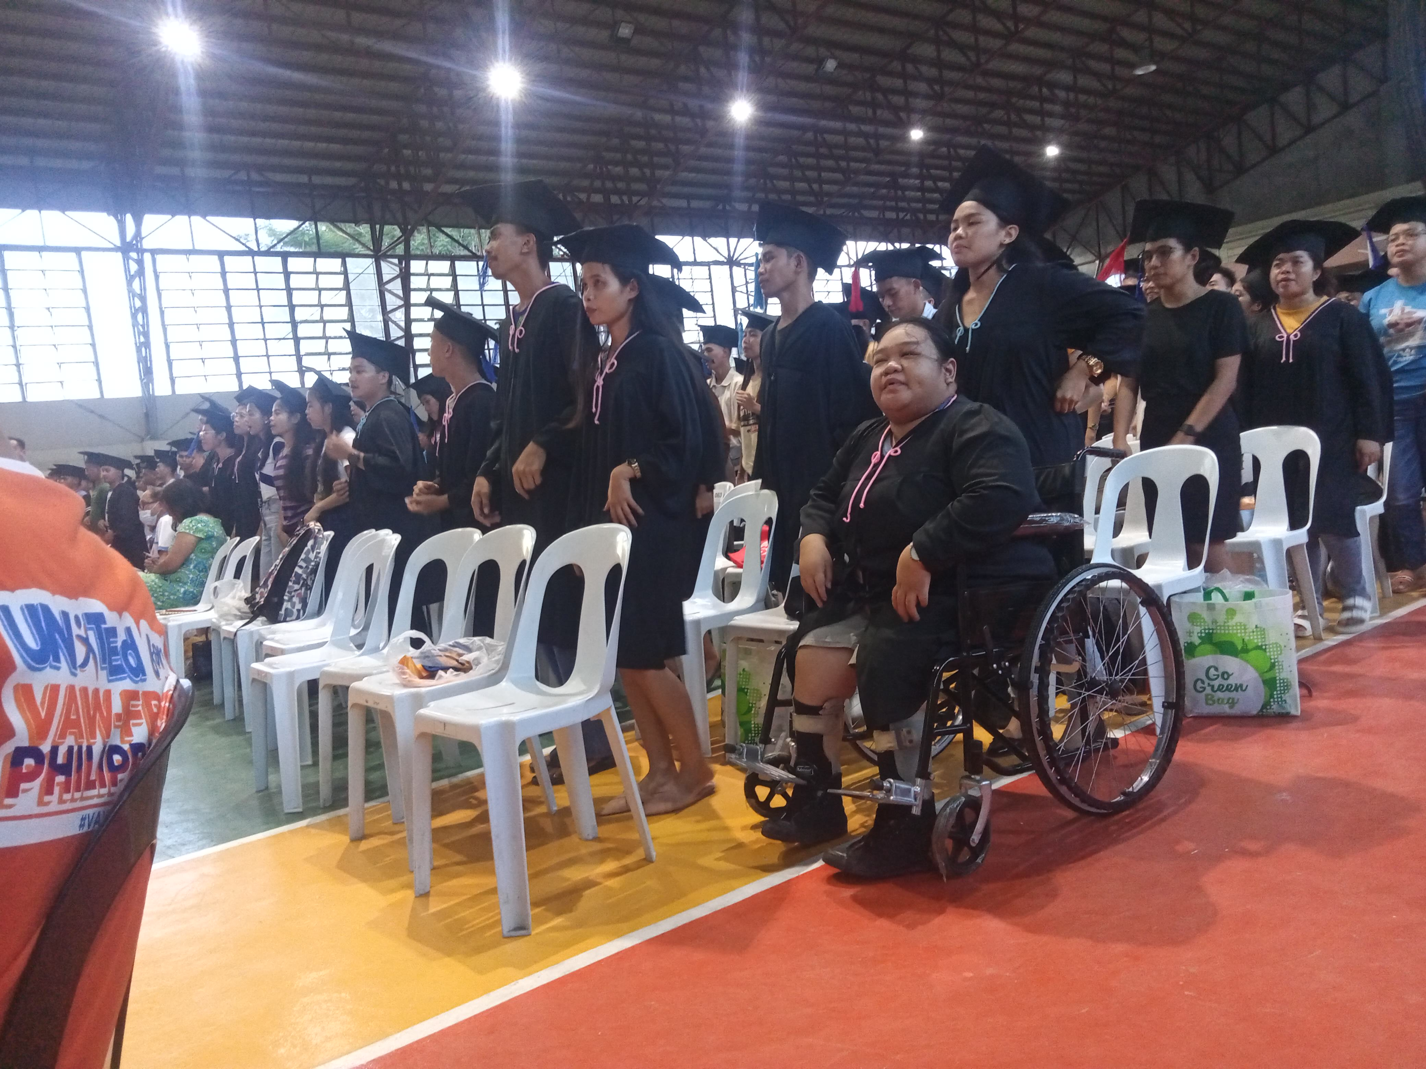

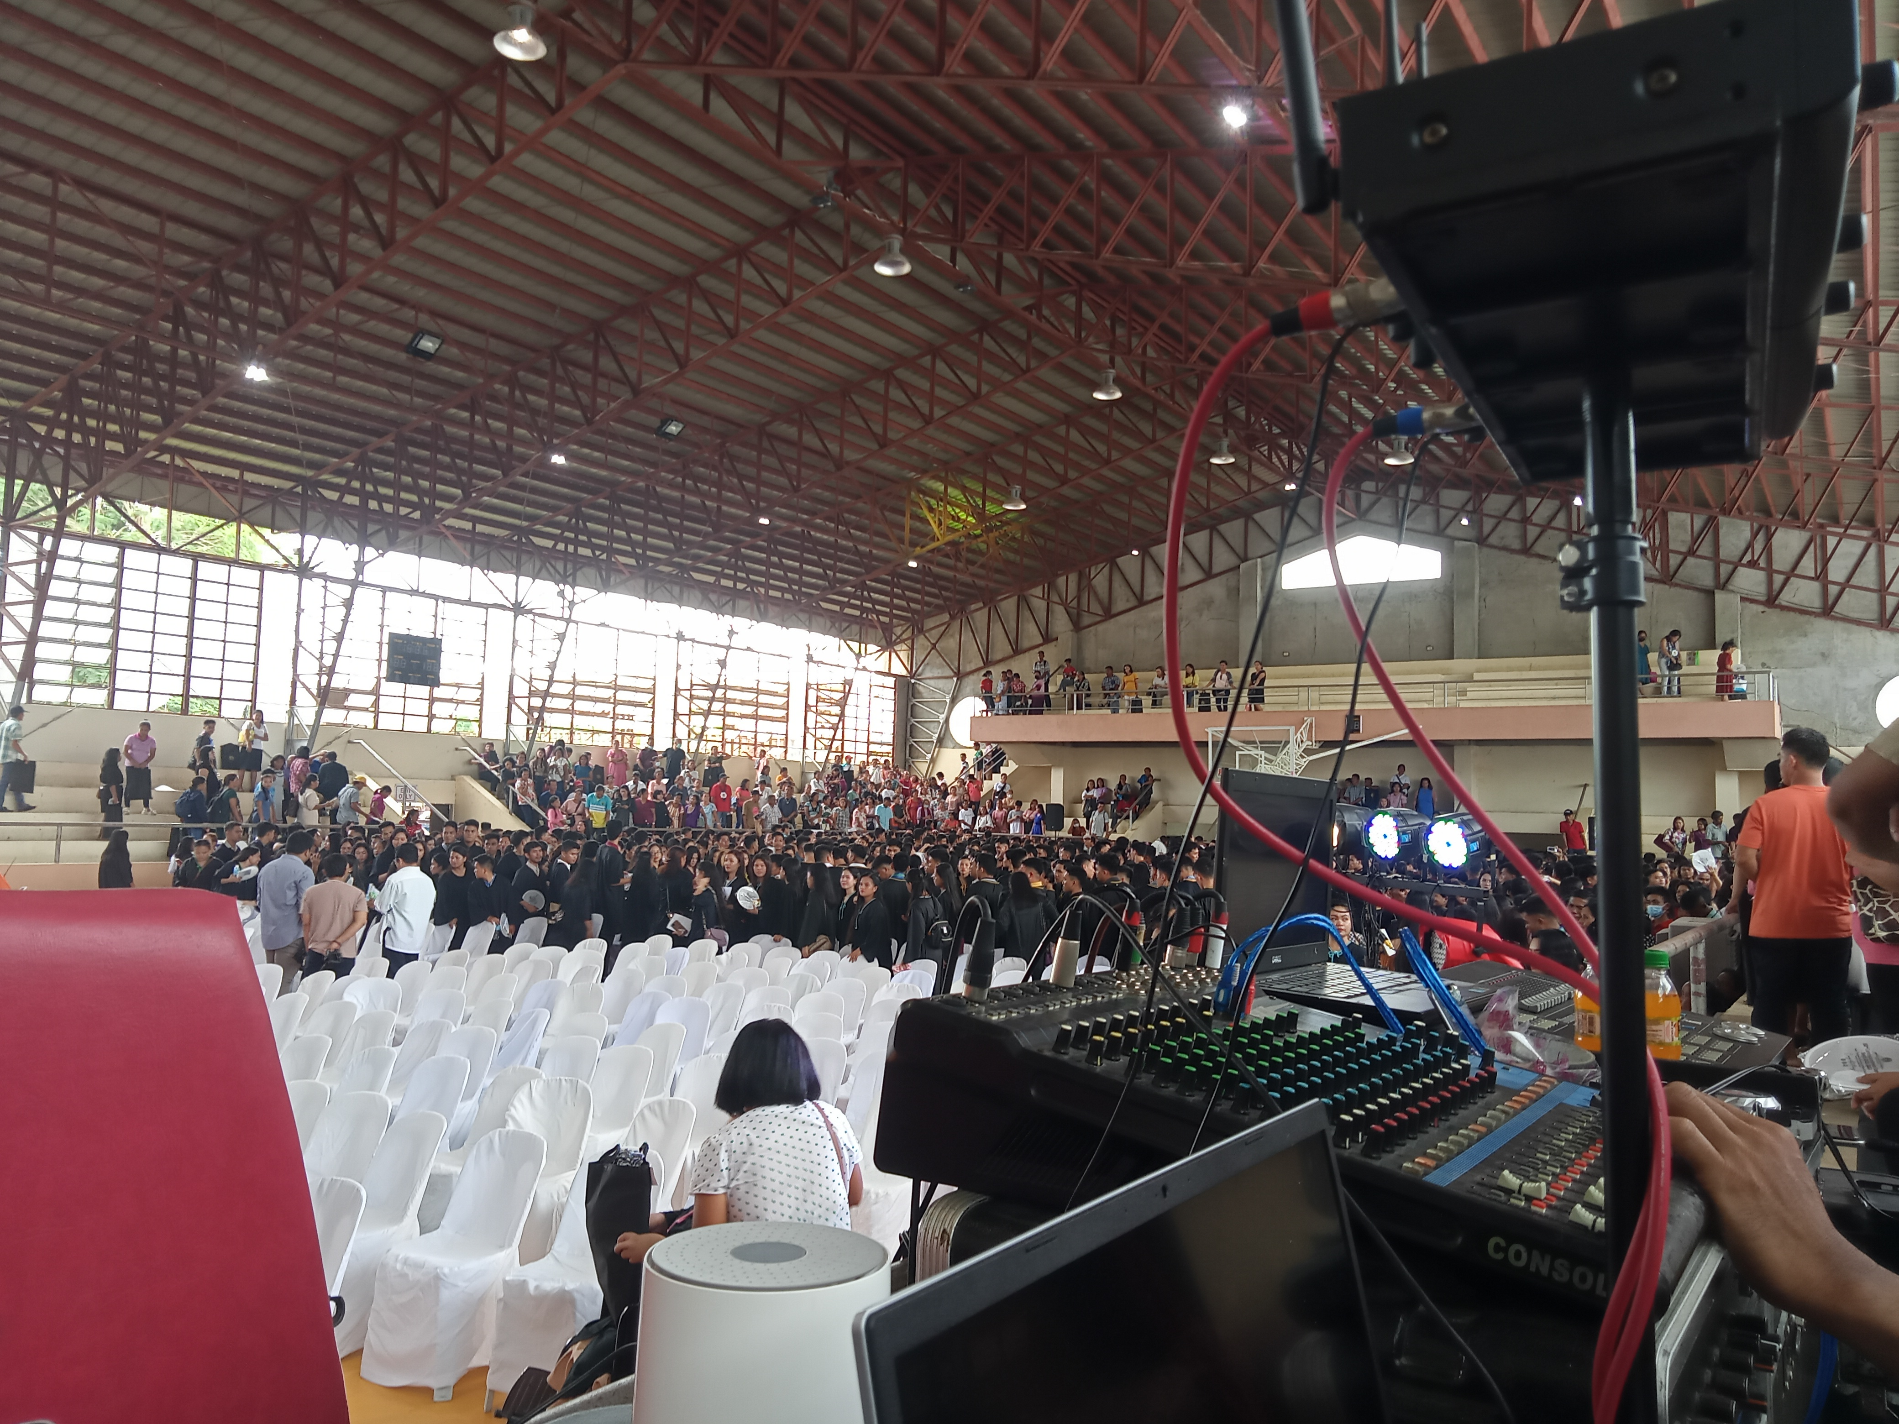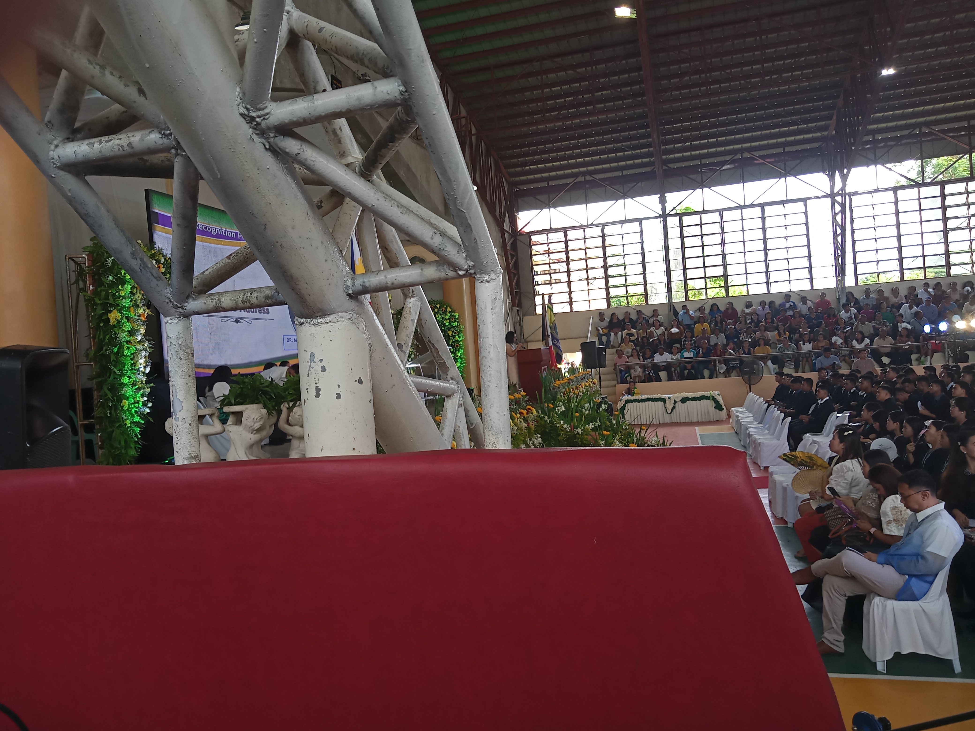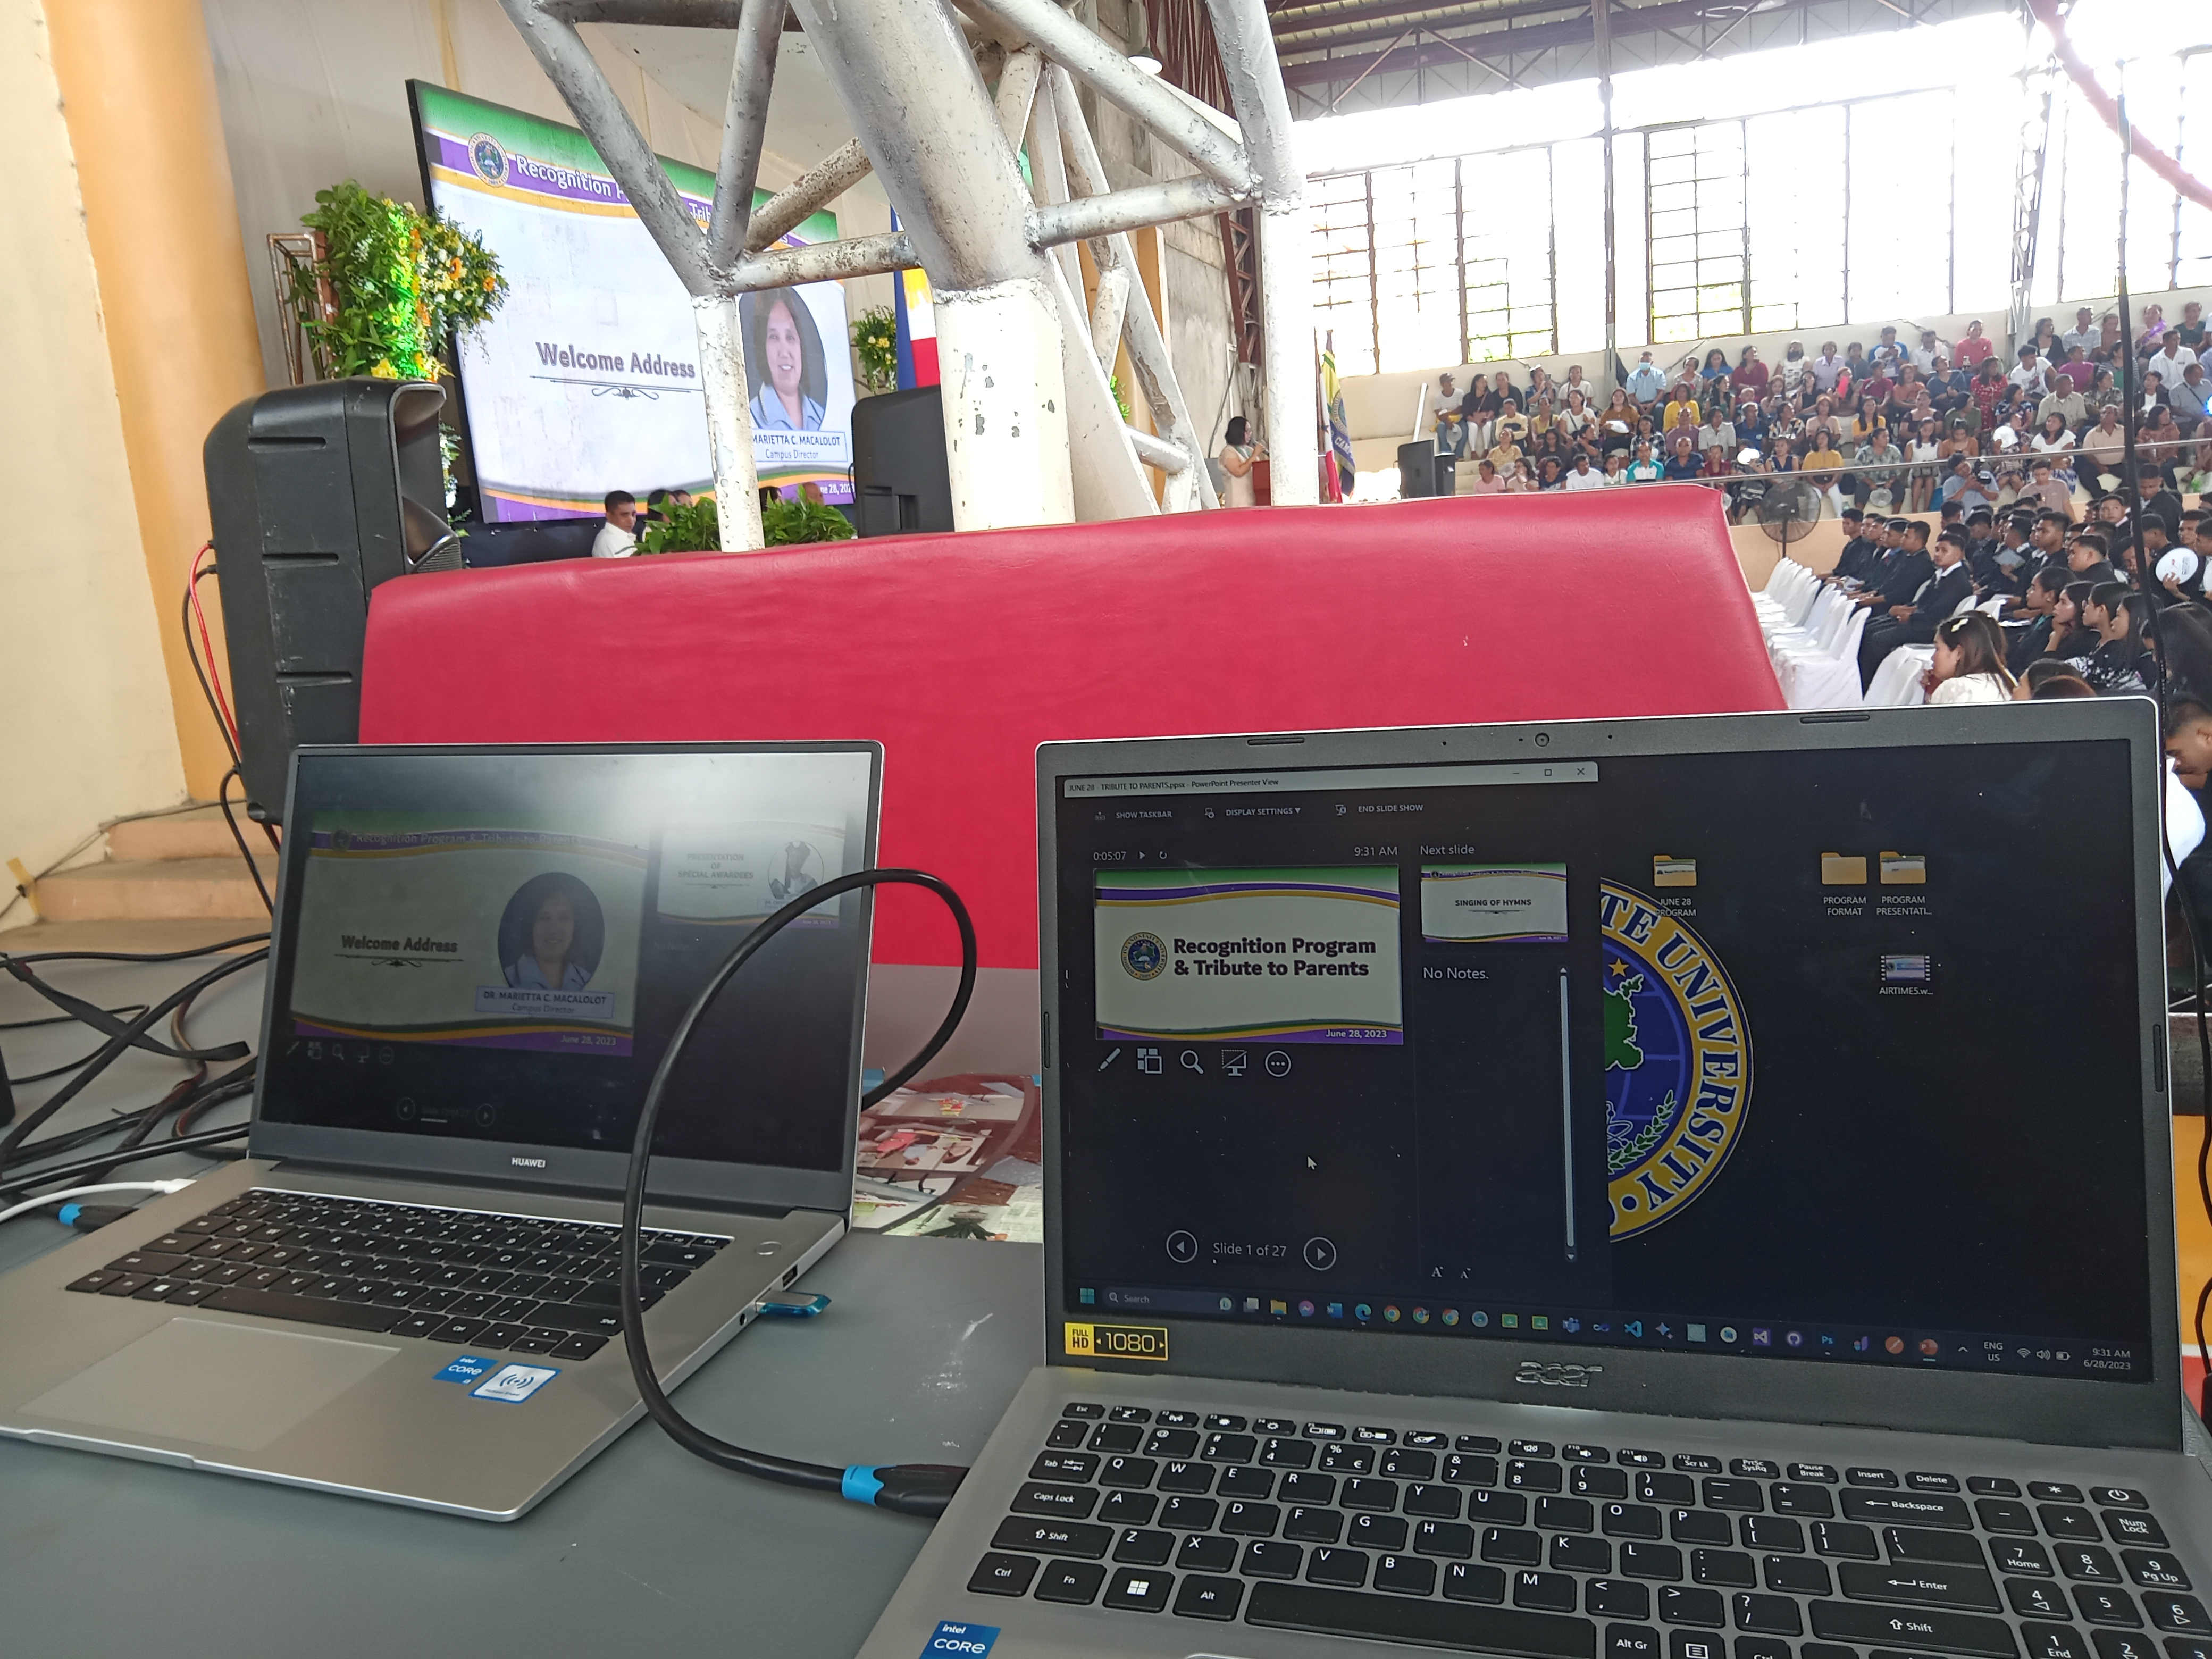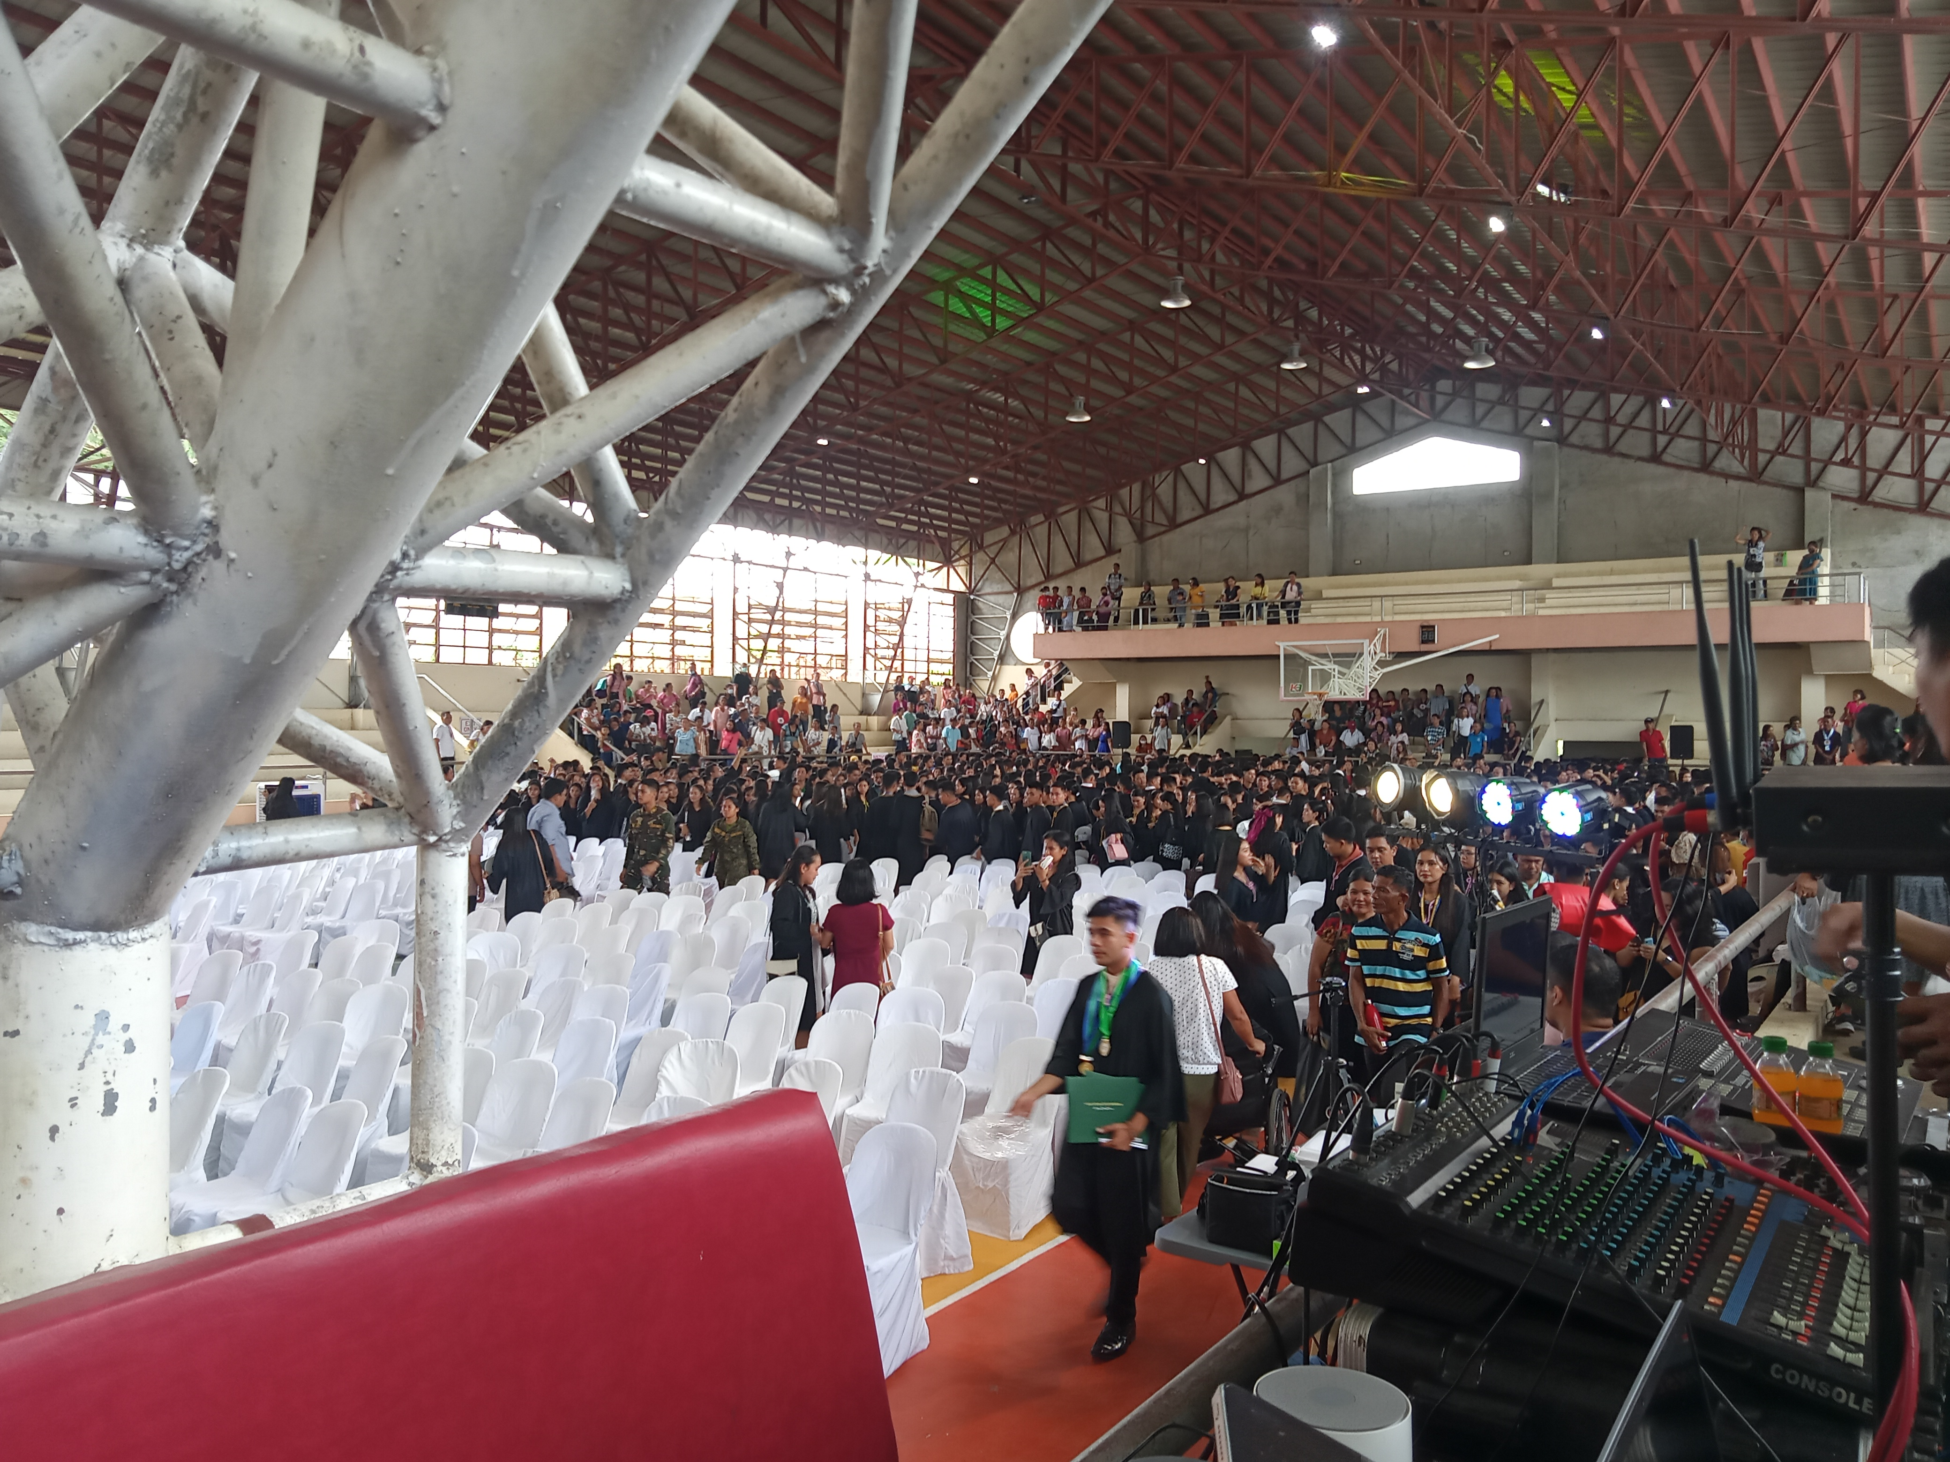

Attach your pictures here :

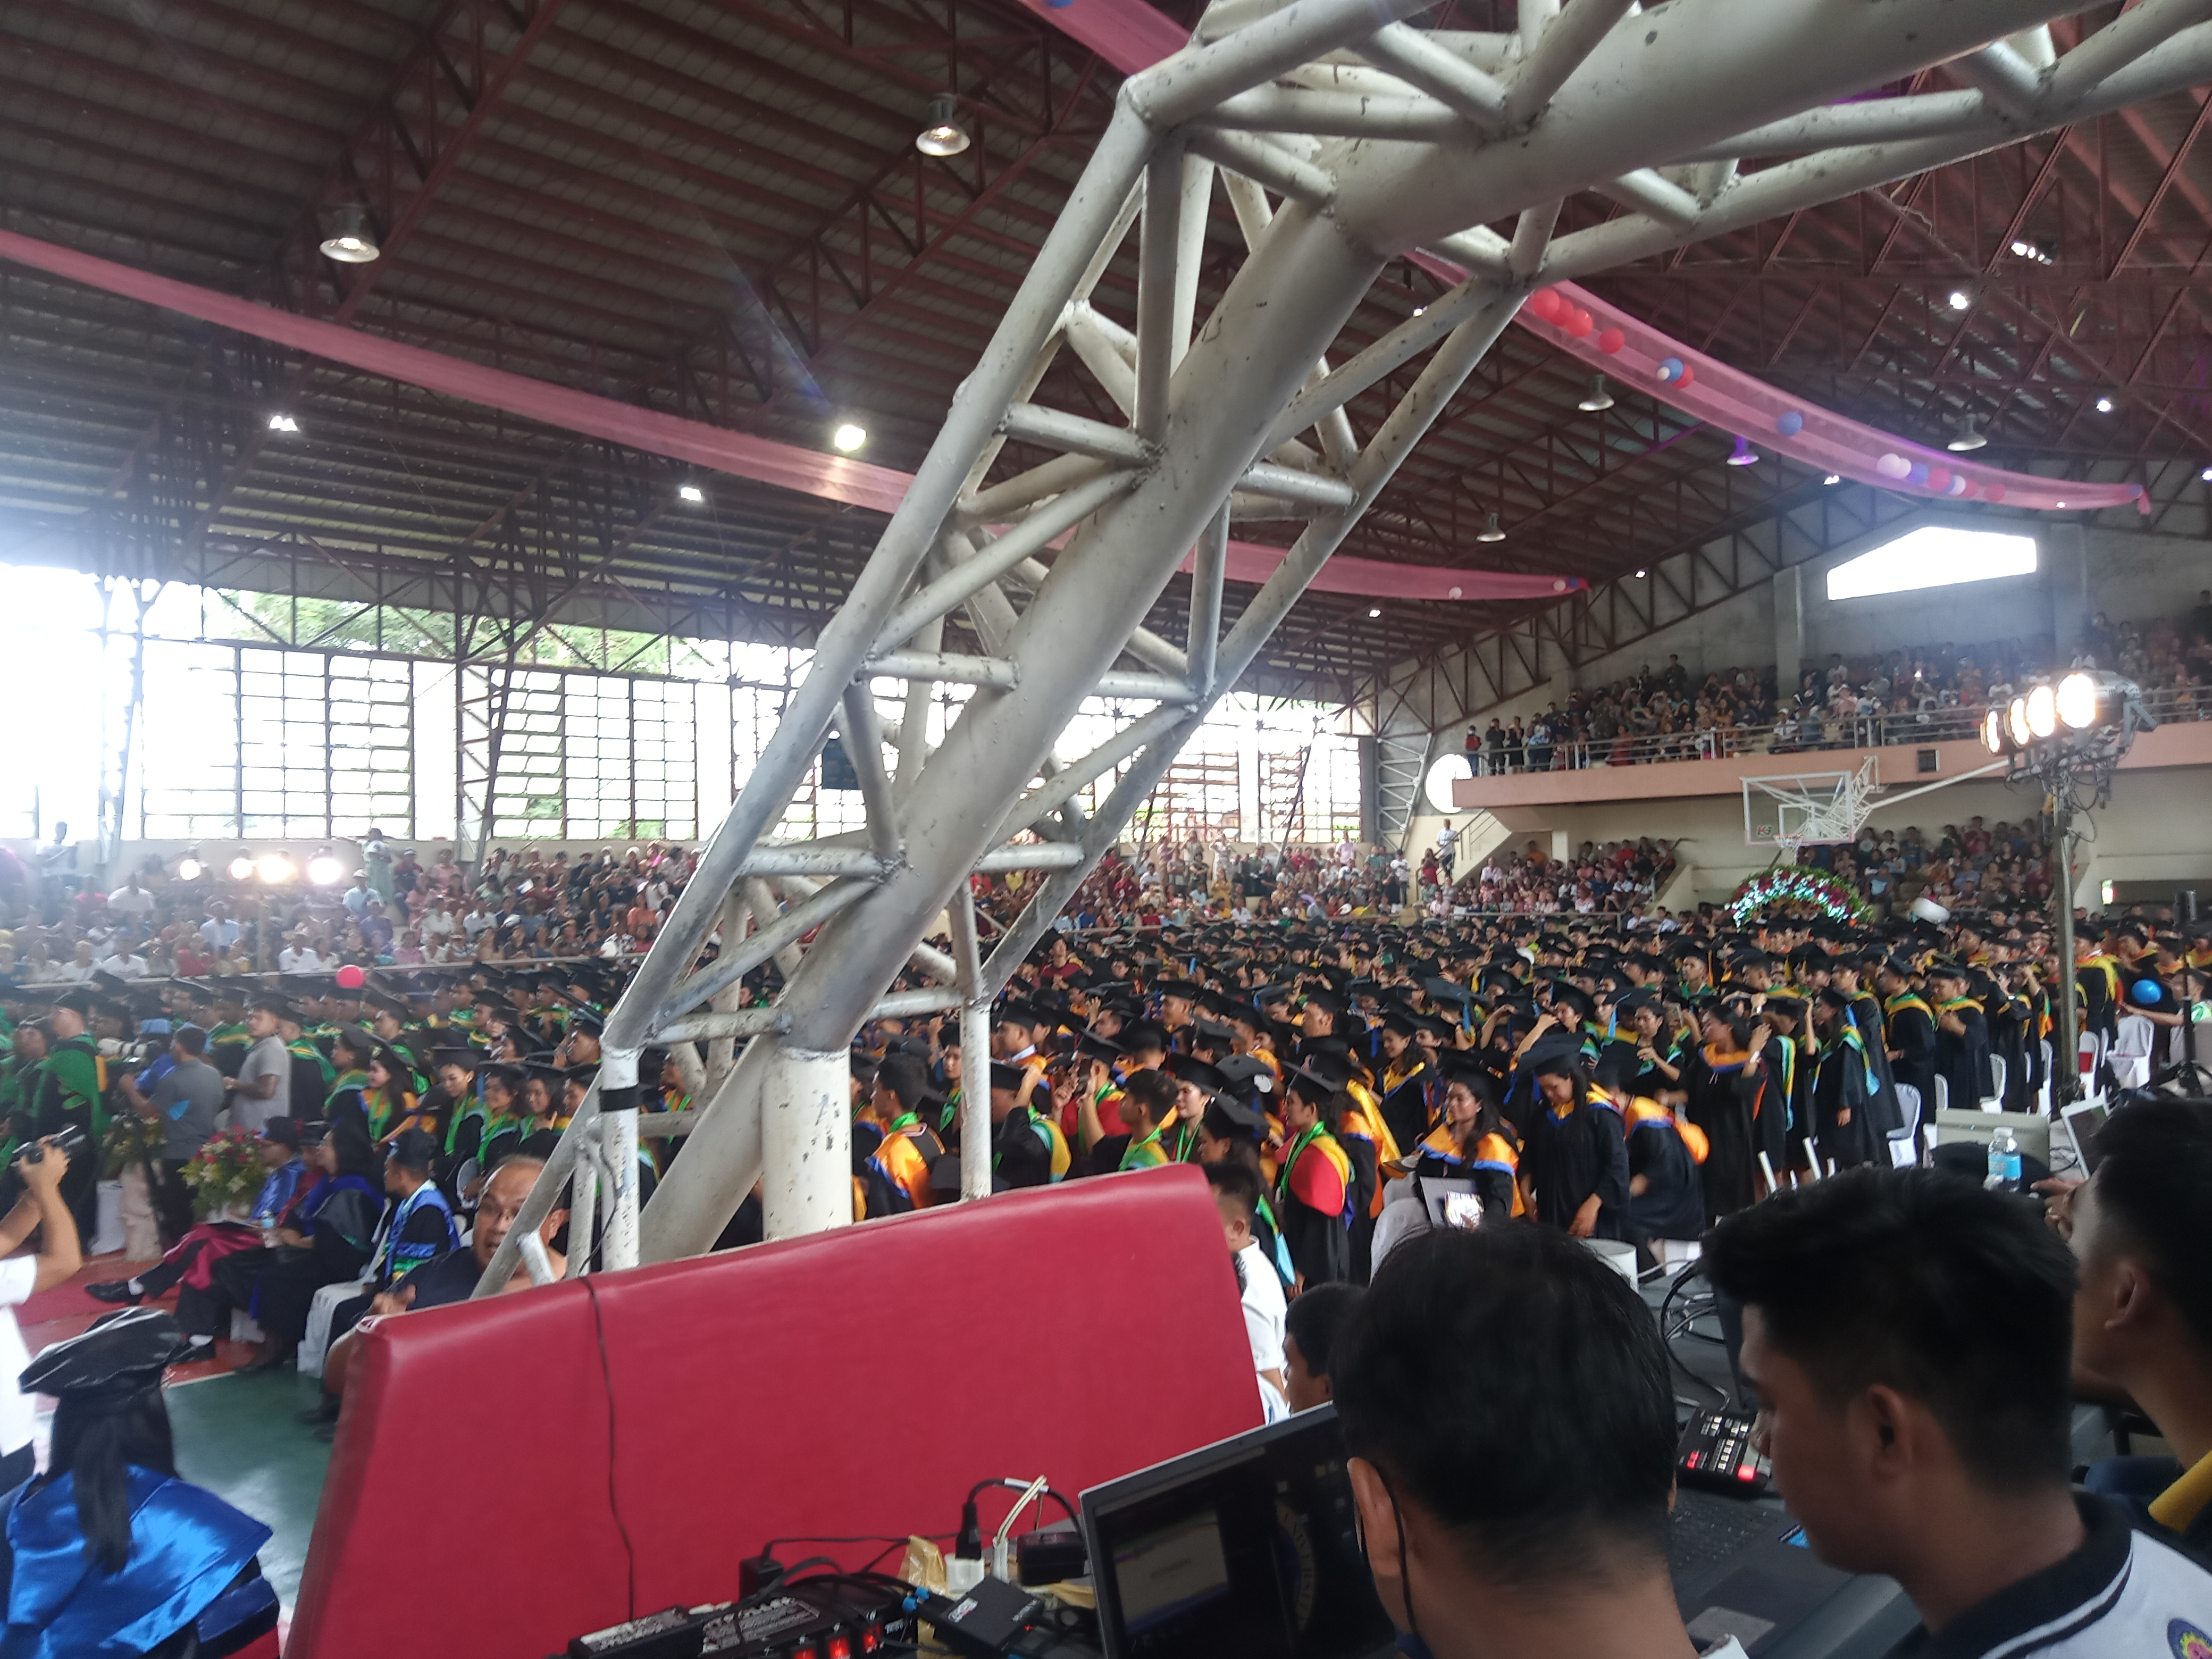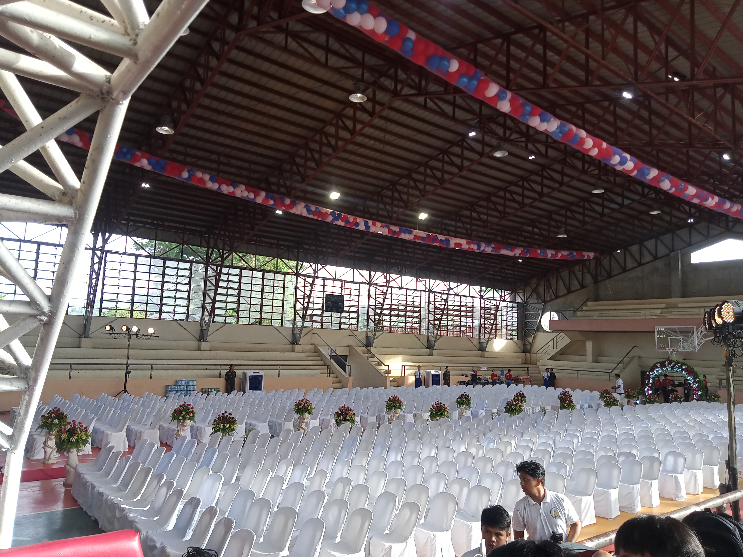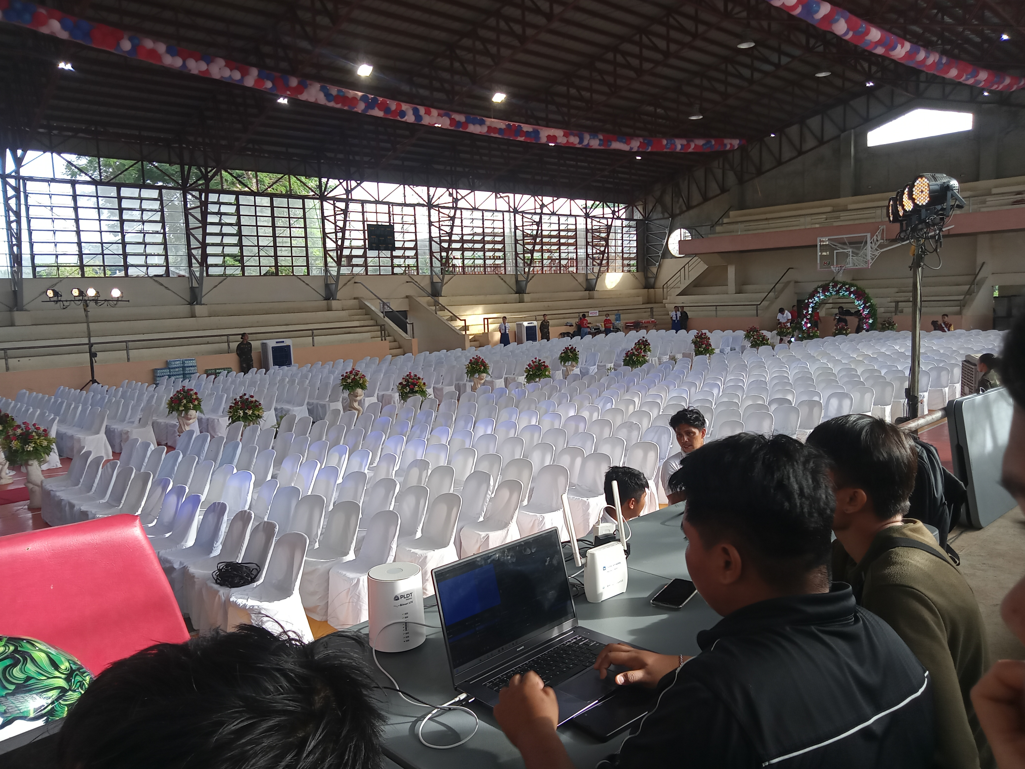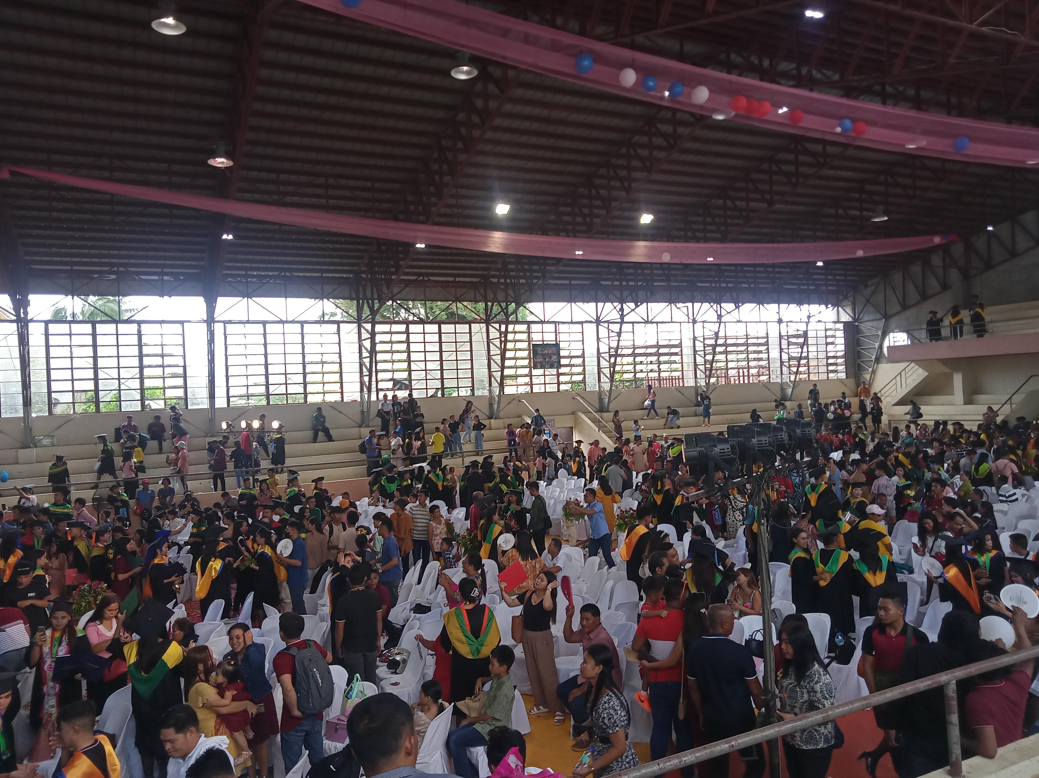

Attach your pictures here :

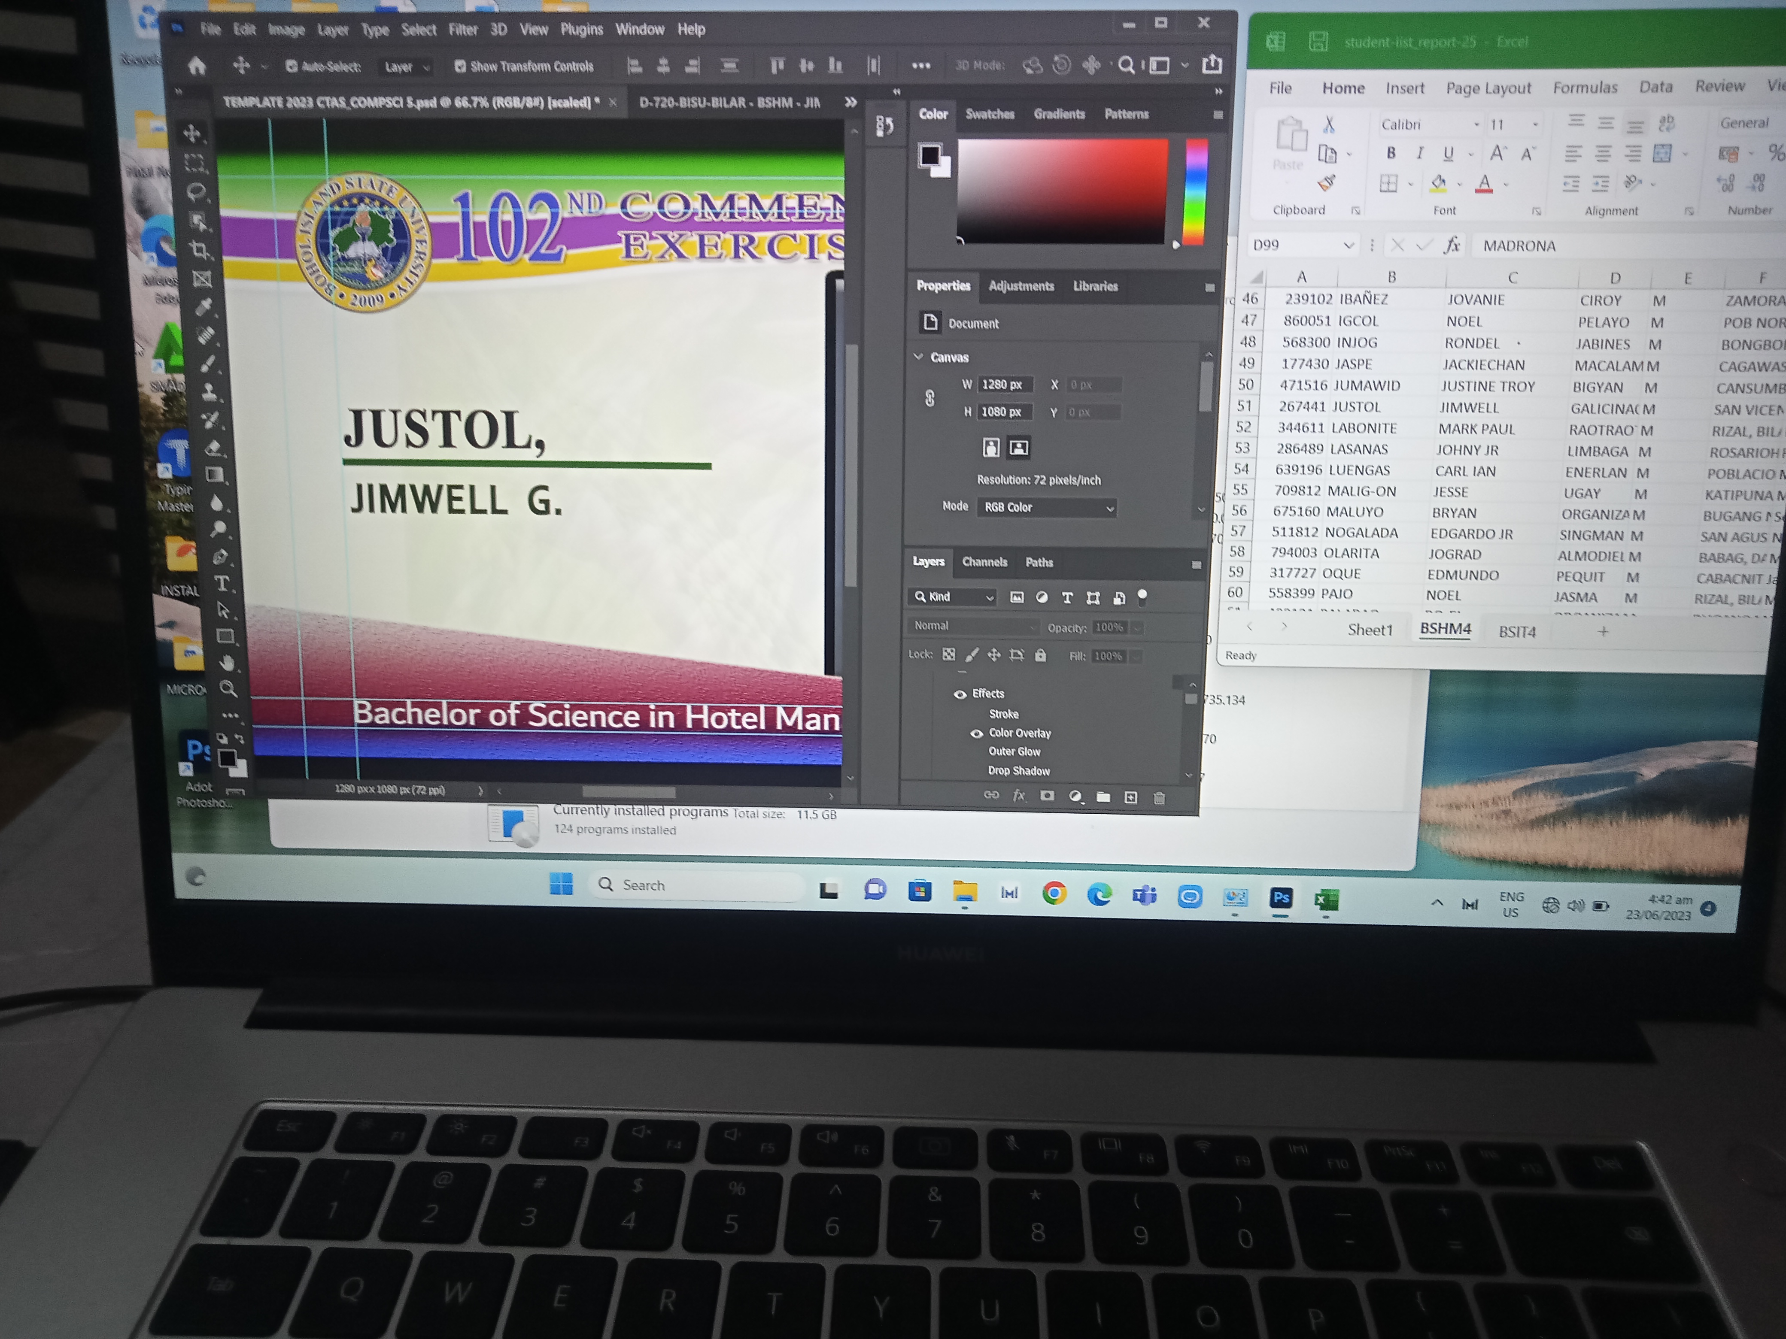

JUNE 23, 2023 (OVERTIME)

4:42 – 6:30 MORNING

